EERD Diagram
By adding specialization/generalization we convert it into EERD.
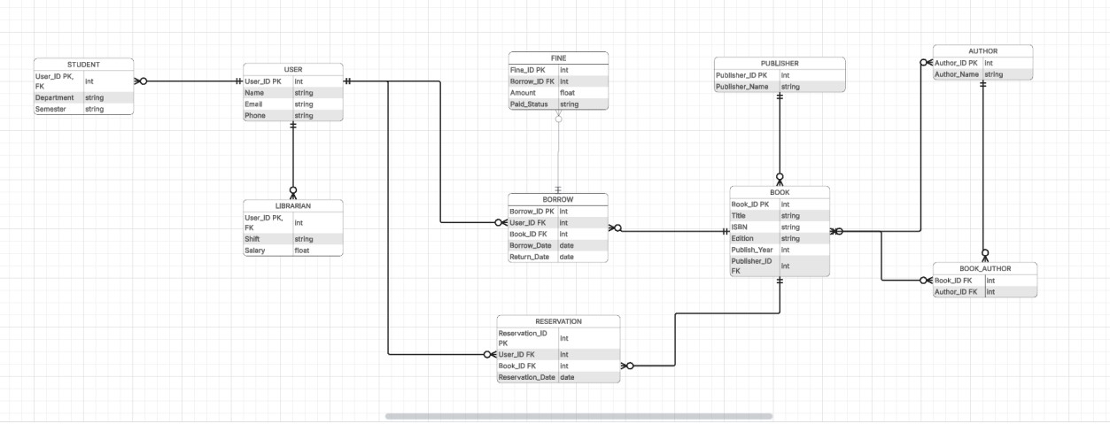
Adding of new entities for EERD Diagram to make it look more clear.
USER Entity
- User as a super class
- Student IS A User
- Librarian IS A User
This is proper specialization/generalization

BORROW Entity
It correctly stores:
- which user borrowed
- which book
- borrow date
- return date
FINE Entity
FINE → linked to BORROW
- Fine depends on borrowing transaction.
RESERVATION Entity
Allows:
- users reserving books before borrowing.

